Project Status Report  
*Blackjack VR game*

# Project Goal

The primary goal of this project is to develop a fully functional VR Blackjack game using Unity 3D, tailored for the Meta Quest 2 headset, while simultaneously gaining expertise in Unity 3D development and VR game creation. The aim is to create an immersive and engaging virtual reality experience that faithfully replicates the ambiance of a real-world casino blackjack table. This involves designing a realistic 3D environment where players can interact with cards and chips, make bets, and engage in gameplay that closely mirrors the traditional rules of blackjack. The end product should be polished and user-friendly, ensuring a seamless VR experience for players.

The project's objectives encompass various aspects of game development, including creating a 3D environment that accurately simulates a blackjack table, featuring intuitive controls for player interaction, and implementing a robust betting system. Depending on progress, there's potential to integrate a 3D model for a dealer, further enhancing the game's realism.

# Project Scope

#### What is considered success?

Success for this project is defined by achieving a functional VR Blackjack game that maximizes the capabilities of the Meta Quest 2 headset. This involves making the cards and chips interactable within the virtual environment. Additionally, success includes implementing animations for card dealing and chip movement when bets are placed through the betting menu. If time permits, there's also a desire to integrate a 3D model for the dealer. While the ideal scenario would be a fully polished game recognizing the constraints, success may also mean achieving a significant level of functionality and interactivity within the given time frame.

#### What are my constraints?

We encounter several constraints in shaping the development of this project. Firstly, our budgetary limitations restrict the acquisition of high-quality 3D models, which may necessitate creative solutions or utilizing freely available assets. Additionally, we face a learning curve as we are unfamiliar with Unity 3D game development and VR headset integration. This will require allocating time for learning and troubleshooting. Moreover, the use of school laptops with relatively weak CPUs and GPUs poses a technical constraint, potentially limiting the complexity and visual fidelity of the game. Finally, time management is a critical constraint, as we must complete the project within a couple of months, alongside other concurrent classes, demanding careful prioritization and efficient workflow management.

#### What is excluded?

The project scope clearly outlines several exclusions. Firstly, multiplayer functionality is excluded, meaning the player will exclusively engage with an AI opponent. This limitation streamlines development efforts and aligns with the defined project goal. Additionally, real-money conversion features will not be integrated, ensuring that the game remains purely recreational without any financial transactions involved. As for player mobility within the virtual space, this will be restricted. The player will be seated and unable to move around or interact with other objects in the virtual room. This simplifies the user experience, focusing on the core gameplay of blackjack without unnecessary complexities. These exclusions help refine the project scope and allow for a more focused development process.

# Research

#### What is new to you in this project, and why does it fit into the class “Explore New Technologies”?

In this project, several aspects are new to us and align perfectly with the core theme of "Explore New Technologies." Firstly, we are delving into the realm of 3D game development using Unity3D, which is a significant departure from our previous experience in coding 2D games. This transition represents a substantial leap in terms of complexity and skill acquisition. We are learning to create a fully immersive 3D virtual reality (VR) environment, which is a technology that has gained significant traction in recent years but is still relatively uncharted territory for us. Learning how to design and develop a VR game is an exciting and cutting-edge endeavor.

Moreover, we are venturing into the domain of VR hardware, specifically the Quest 2 VR headset. The process of setting parameters to ensure that the VR experience is seamless and comfortable for the user is a novel challenge. This includes optimizing performance, creating an immersive interface, and understanding the intricacies of how VR hardware interacts with the software. Additionally, we are learning to create a build on the VR hardware, which involves understanding how to port our Unity project to run on the Quest 2 VR headset.

All these aspects align perfectly with the "Explore New Technologies" class because they encapsulate the essence of what this course is about. This course is designed to expose students to emerging information technologies, and VR, especially in the context of game development, is at the forefront of technological innovation. By learning how to harness the power of Unity3D for VR game development and understanding the intricacies of the Quest 2 VR hardware, we are not only exploring new technologies but also equipping ourselves with skills and knowledge that are highly relevant in today's tech-driven world. This project challenges us to think beyond traditional 2D game development and opens up new horizons in the realm of immersive, cutting-edge experiences. It's a prime example of why this project is a perfect fit for a class dedicated to exploring and embracing new technologies.

#### What are your primary sources for this project, and how did you find them?

Our sources for our project are the following, a playlist of tutorial videos (Valem Tutorials, 2022) that we used to be able to start the project from scratch. Another source we used was an online set of rules for the blackjack game (Bicycle Cards, 2020), so we were able to understand the basic rules and how blackjack works. We also had to get some assets from Unity’s asset store to be able to create our environment scene. For the casino model, we found an asset (Lumo-Art 3D, 2020) that already had all the components we needed, so we purchased it for our project. For the hands model, we found a realistic model (NeoCube, 2017), which we bought, so our hands looked more similar to those of a human being. We also had to access a YouTube tutorial video (Barnett, 2021) to learn how to interact with buttons and implement them in our game. We also had to look at a Wikipedia article (Fusy, 2023) to understand how to implement a shuffle algorithm so we would be able to shuffle the cards before dealing them to the player and the dealer. We also had to follow a YouTube tutorial (The AR VR Guy, 2023) to be able to test our game through Unity, set our VR in developer mode, connect it via the Link Cable or WiFi connection, and finally get Unity to recognize it and be able to run the blackjack game prototype. We had two YouTube videos that helped us troubleshoot some issues we were encountering throughout the development process. The first video, a YouTube tutorial (UGuruz, 2021), helped us fix some issues we had when importing the casino and the hand models. The first time we included the models in our project, the mesh color was pink; we were not able to see any other colors. We learned in the tutorial that we had to change the pipeline formatting to Universal Rendering Pipeline. For our last source, we had to create a build of our game to be able to run the game in our VR headset because we were not able to run the game on our school laptops. To be able to do so, we followed a YouTube video tutorial (Circuit Stream, 2022) that helped us reach this goal and be able to try the game when not having the minimum requirements in our computers to do so via the computer GPU.

# Tasks within the group

#### What is each group member responsible for?

**Elijah:**   
 In this project, I have been responsible for the game/code logic. I will be making the methods that display the cards and will be working on finding an algorithm to shuffle the cards properly whenever the card amount gets too low. If there is enough time at the end of our project, I will be looking into how we can get character models to represent the dealer and the player characters.

I am also going to be looking into win/lose conditions for our game. For this, we will need to mainly implement a method that checks if the player or dealer busts with over 21, as well as comparing the values of the cards in either’s hands to determine who the winner is. We must be able to pull cards at random from a deck array and then instantiate those card prefabs on the blackjack table.

In the future, I will be working on getting the hit/stand/double/split buttons working properly. They should all do as they are expected to in a real game of blackjack. I plan to have them instantiate with a constant variable of x and z, allowing each card to be dealt face up in a line in front of the player, or dealer.

So far in the project, I am ahead of schedule. We decided to scrap the card interaction altogether for the time being, as it does not feel necessary right now. We would rather focus on having the actual logic of the game work properly, rather than having the cards be moveable.

At this time I am working on implementing the methods that will hit/stand/double/split, and also checking for busts after every decision.

**Munir:**

In this project, I’m responsible for making the build of the game and seeing if the hands work, but the hand tracking is not working in the build, but it works while running the game in the Unity editor. I followed a YouTube tutorial (Circuit Stream, 2022) for making the build of the VR game but still, the issue is not solved.

I made the button prefab so that we can use that button for different actions in the game like Hit, Stand, Double, or Split. I had to watch a YouTube tutorial (Barnett, 2021) to be able to do these tasks.

I researched the rules and game mechanics of the BlackJack game on the internet (PlayingCardDecks.com, 2019) to have a better understanding of how this game works. I started playing the BlackJack game on my phone to completely understand this game.

I looked for an asset of a Start Menu in the VR game and I found one (Valem VR, 2023), then I implemented that asset in the game so we have a Start Menu UI in our game with several buttons.

I’m working on creating the UI of a betting system so the player can set an amount of chips to bet on. I’m going to create this UI to be close to the player and be visible enough.

I’ll be working on the game mechanics and how the player or dealer is going to win or lose. I’ll be working on the BlackJack rules in the project.

I did some research and followed the YouTube tutorials from the tutorial playlist (Valem Tutorials, 2022) to be able to do my part.

**Vladimir:**

At the beginning of the project, I was tasked with getting the Github repository up and running and gaining a thorough understanding of how to interact with Unity 3D in the context of Virtual Reality (VR) development.

I had to create the Unity Project from scratch and follow the first five videos from the tutorial playlist (Valem Tutorials, 2022) to have the hands, the character, and the interactable objects working.

I was also tasked with attempting to create a build of the project. I spent around 2 hours debugging and trying different solutions (Circuit Stream, 2022) to address the issue of doing a build on my laptop. Although I encountered lots of obstacles and had to cancel the process, I demonstrated initiative in taking on this technical task.

I had the responsibility of reaching out to Francis and searching for tutorials for guidance and answers to any issues that arose during the development process. This included technical queries, the pink sprites situations dealing with the build, and seeking advice on how to proceed with certain aspects of the game.

I took on the responsibility of fixing the imported assets, ensuring that they appeared correctly and were no longer pink. I was also responsible for implementing the new hand models into the project. In addition, recently, I merged the casino scene made by Munir with the main scene which we were all working on, and I set the character’s position at the blackjack table.

With the other team members, I began analyzing how to approach the coding aspect of the project for the last steps before its implementation and I have been starting to look for examples of game mechanics to make the game function properly.

# Required Hardware and Budget

For this project, we need a VR Oculus Quest to be able to develop the game and play the build version of the game. Nowadays, an Oculus Quest 2 costs around $420. Fortunately, all our team members have the Oculus Quest 2 so we did not have to buy VR Oculus Quest 2. Obviously, we need a laptop or a desktop computer to be able to develop the game.

There are some minimum requirements for the Oculus Quest 2 system to link the headset with the PC. These include a minimum CPU equivalent to an Intel Core i5-4590, a minimum graphics card equivalent to a NVIDIA GeForce GTX 970, and a minimum of 8GB of RAM (Meta, 2023) .

# Required Software and Budget

For this project, we had to buy two assets which are the Casino Environment (Lumo-Art 3D, 2020) and the Hand for VR (NeoCube, 2017). The Casino Environment cost us 45$ and the Hand for VR cost us 15$. We did not pay for the assets but the college did.

We need a game engine program to be able to test and develop the game. We used the Unity game engine for this project. It is a famous game engine for making video games in 2D and 3D.

To work in a team we need to manage the source code and the work we did so the other team members can have our code or our work in their project so everyone can be on the same path. So, we used GIT Extension to share our code and the changes we made in the project. We used Trello to divide some tasks and assign each task to each of us, so we could start working on specific tasks and have a good improvement.

# Schedule

| Week | **Description** | Elijah | Vlad | Munir |
| --- | --- | --- | --- | --- |
| 1 | Gather information | Picked project, formed team | | |
| 2 | Gather information | Looking for assets and software | | |
| 3 | Gather information | Setting up the project in Unity, learning rules for VR games | | |
| 4 | Plan project steps | Implemented the assets, began hand tracking and interactivity | | |
| 5 | Plan project steps | Divide the work we have to do in the future | | |
| 6 | Decide on an approach | Working on code | Create a build | Work on the UI, menu, and buttons. |
| 7 | Decide on an approach |
| 8 | Execute | Shuffling Algorithm and coding logic | Fix the hands model and set the player in the proper place | Fix the hand tracking after the build |
| 9 | Execute | Work on the project status and journal entry |
| 10 | Execute | Displaying cards on the table | Work on the code and connect the logic  to the different buttons | making a UI for showing the bet |
| 11 | Execute | Improve the code (Manage win/lose scenarios) | Focus on getting the betting system to work | Work on the rules and the game mechanics(Manage win/lose scenarios) |
| 12 | Execute | Improve the code | Improve the code related to the dealer AI when  having to decide whether to hit or fold | Improve the code |
| 13 | Test product | Finding Testing and fixing bugs | Be sure to get a build working | Finding Testing and fixing bugs |
| 14 | Test product | Finding Testing and fixing bugs | Finding Testing and fixing bugs | Finding Testing and fixing bugs |
| 15 | Rate project | Prepare PPT presentation | Prepare PPT presentation | Prepare PPT presentation |

# Current Status

Note: Screenshot s, photos and videos (linked) are helpful here.

**Main menu for our game**

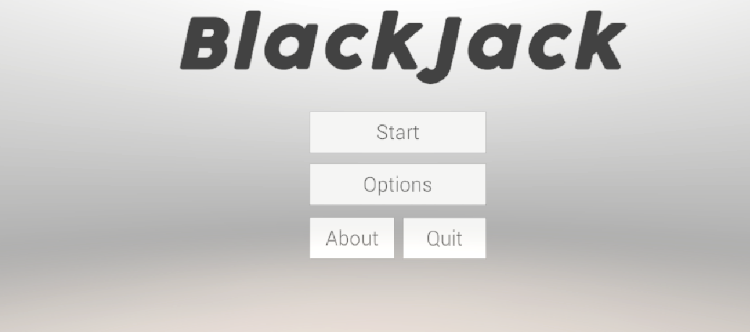

**Options menu**

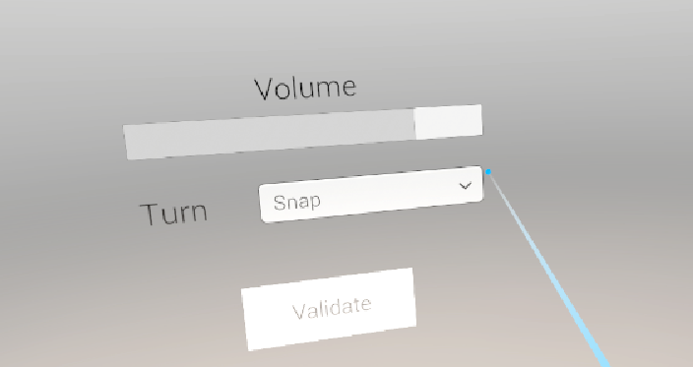

**Surrounding environment**

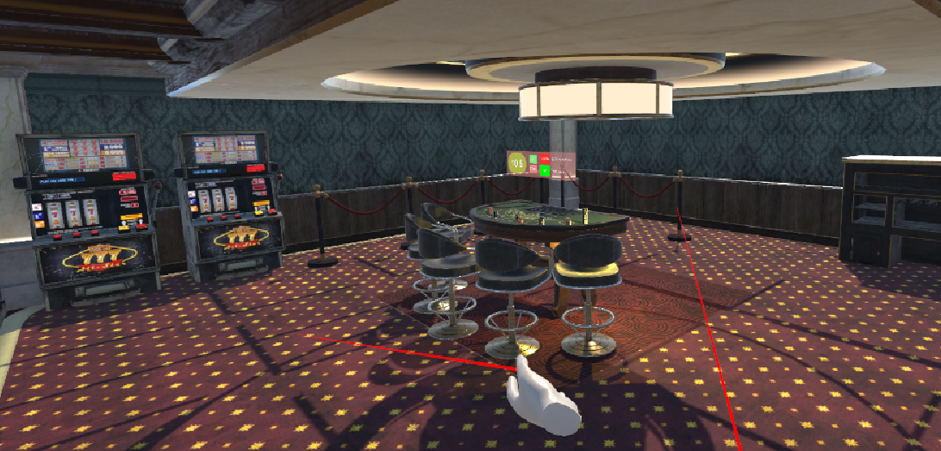

**Game view**

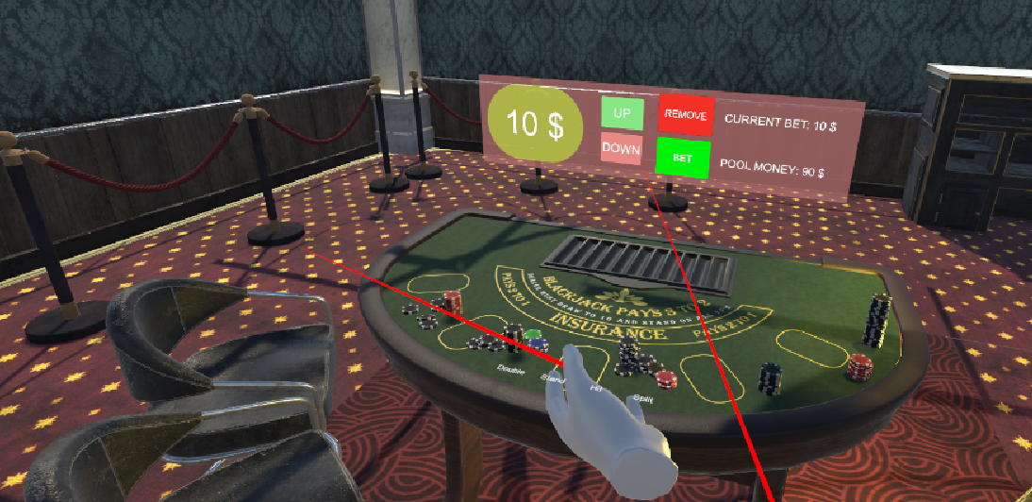

**Prototype for card dealing (Hitting the hit button makes two cards be dealt) The button material disappears in the play scene, as demonstrated here. It is a known bug which we will fix.**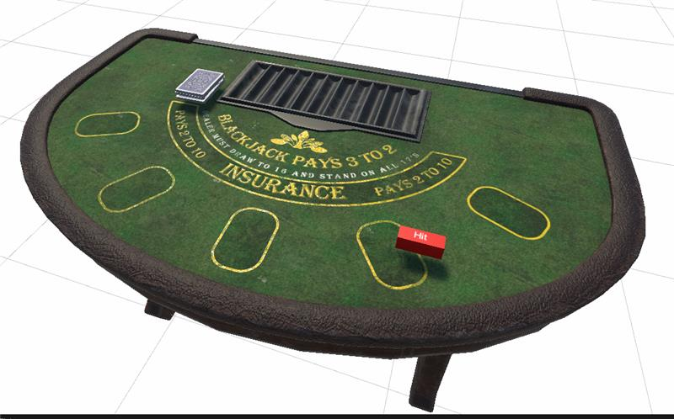

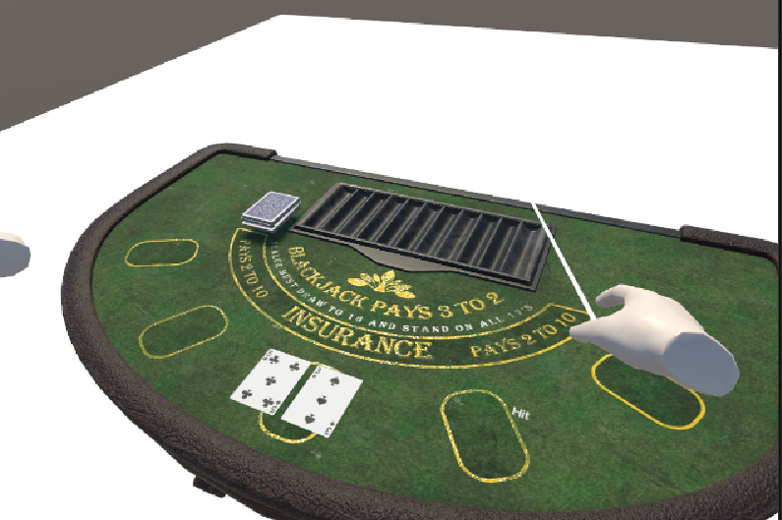

# References

The AR VR Guy. (2023, February 12). *Meta Quest 3 & Unity Set-up for VR Development 2023*. Meta Quest 3 & Unity Set-up for VR Development 2023 - YouTube. Retrieved September 1, 2023, from https://www.YouTube.com/watch?v=xX7NwVChGMM

Barnett, J. P. (2021, March 19). *A Beginner's Guide to Making VR Buttons*. A Beginner's Guide to Making VR Buttons - YouTube. Retrieved August 28, 2023, from https://www.YouTube.com/watch?v=HFNzVMi5MSQ

Bicycle Cards. (2020). *LEARN TO PLAY Blackjack*. Blackjack. Retrieved August 24, 2023, from https://bicyclecards.com/how-to-play/blackjack/

Circuit Stream. (2022, June 14). *Beginner's Guide to Unity: Building Unity Projects for Oculus Quest 2*. Beginner's Guide to Unity: Building Unity Projects for Oculus Quest 2 - YouTube. Retrieved September 11, 2023, from https://www.YouTube.com/watch?v=NWBc0y95obc

Fusy, É. (2023, October 11). *Fisher–Yates shuffle*. Wikipedia. Retrieved August 30, 2023, from https://en.wikipedia.org/wiki/Fisher%E2%80%93Yates_shuffle

Lumo-Art 3D. (2020, January 15). *Casino Environment Pack*. Casino Environment Pack | 3D Interior | Unity Asset Store. Retrieved August 25, 2023, from https://assetstore.unity.com/packages/3d/props/interior/casino-environment-pack-55621

Meta. (2023, 10 22). *Requirements to use Meta Quest Link*. Requirements to use Meta Quest Link | Meta Store. Retrieved August 28, 2023, from https://www.meta.com/help/quest/articles/headsets-and-accessories/oculus-link/meta-quest-link-compatibility/

NeoCube. (2017). *Hand for VR*. Hands for VR. Retrieved August 25, 2023, from https://assetstore.unity.com/packages/3d/characters/humanoids/humans/hand-for-vr-96403#description

PlayingCardDecks.com. (2019, August 19). *How to play Blackjack & Game Rules With Video*. How to play Blackjack & Game Rules With Video – PlayingCardDecks.com. Retrieved September 11, 2023, from https://playingcarddecks.com/blogs/how-to-play/blackjack-game-rules

UGuruz. (2021, May 10). *How to fix pink materials in unity*. How to fix Pink Materials in Unity - YouTube. Retrieved September 10, 2023, from https://www.YouTube.com/watch?v=nB0r0c-SIVg

Valem Tutorials. (2022, July 17). *How to make a VR game - Unity XR Toolkit 2022*. YouTube. Retrieved August 23, 2023, from https://www.YouTube.com/playlist?list=PLpEoiloH-4eP-OKItF8XNJ8y8e1asOJud

Valem VR. (2023, June 5). *VR-Game-Jam-Template/Assets at main · ValemVR/VR-Game-Jam-Template*. VR-Game-Jam-Template/Assets at main · ValemVR/VR-Game-Jam-Template. Retrieved September 10, 2023, from https://github.com/ValemVR/VR-Game-Jam-Template/tree/main/Assets